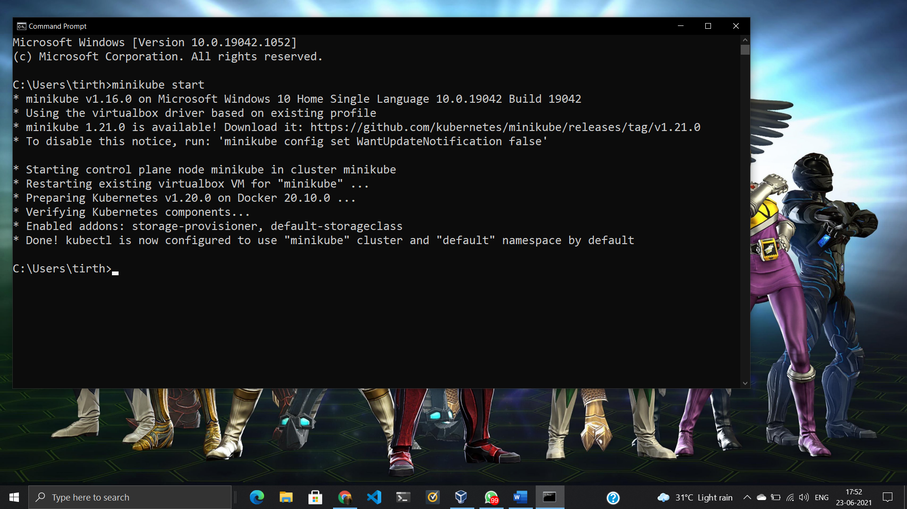

Login to Minikube VM.

User Name: **docker**

Password: **tcuser**

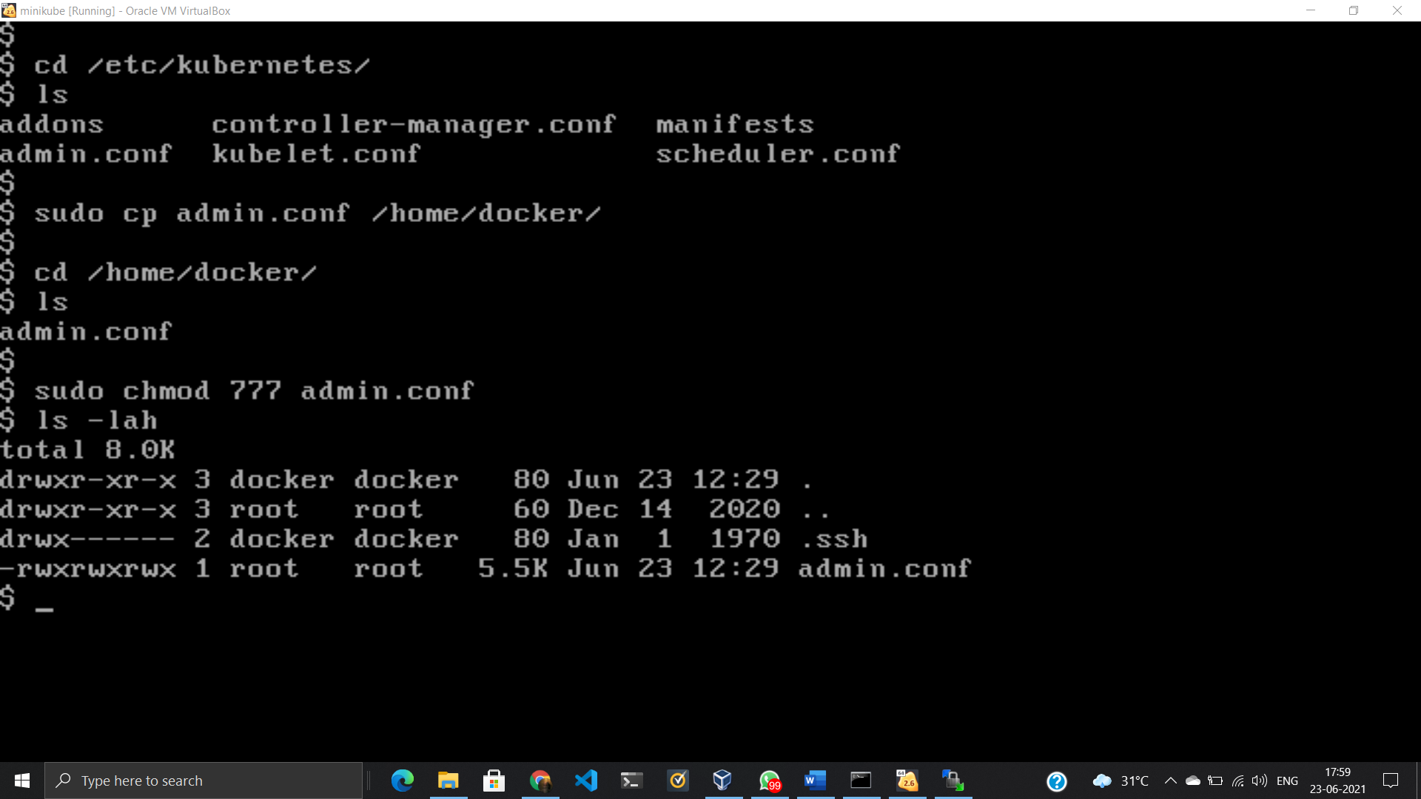

We change the permissions of admin.conf file so that we can copy this file from here to Windows Machine. And afterwards we need to transfer this file to RHEL8 VM.

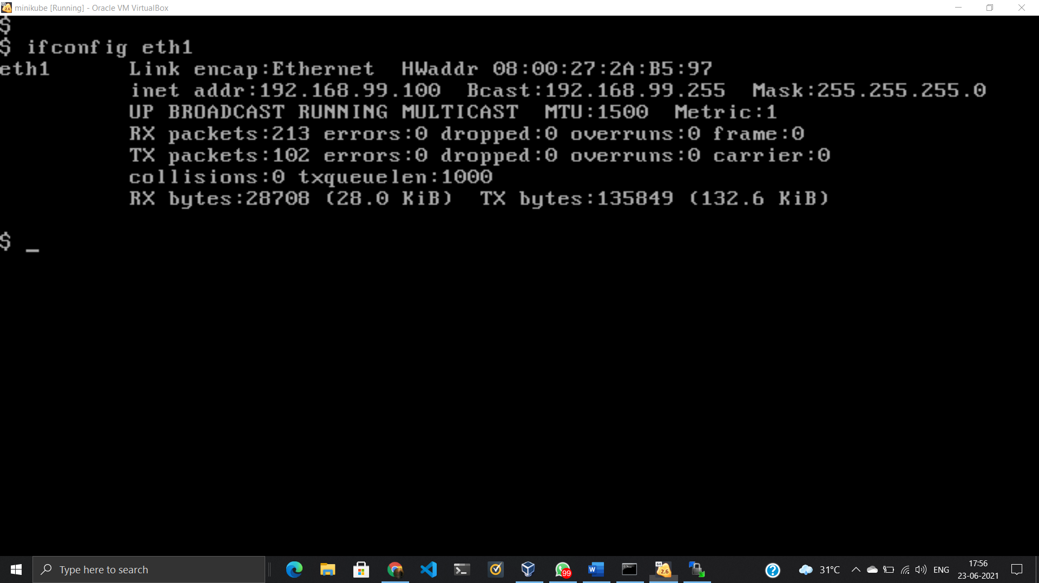

Using WinScp we can transfer file from remote machines or VM’s.

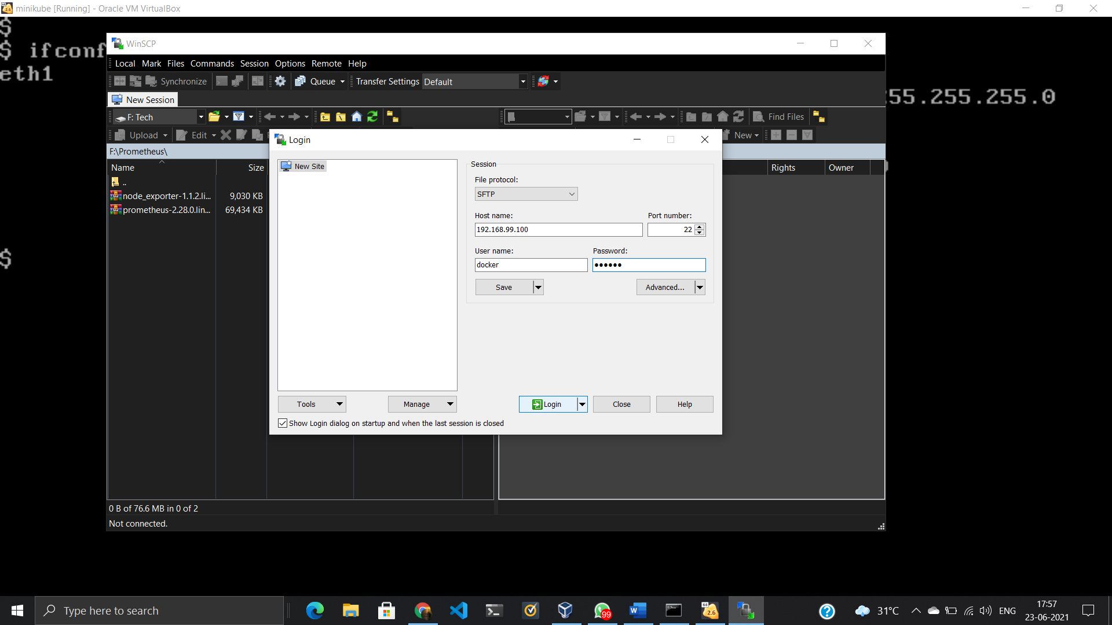

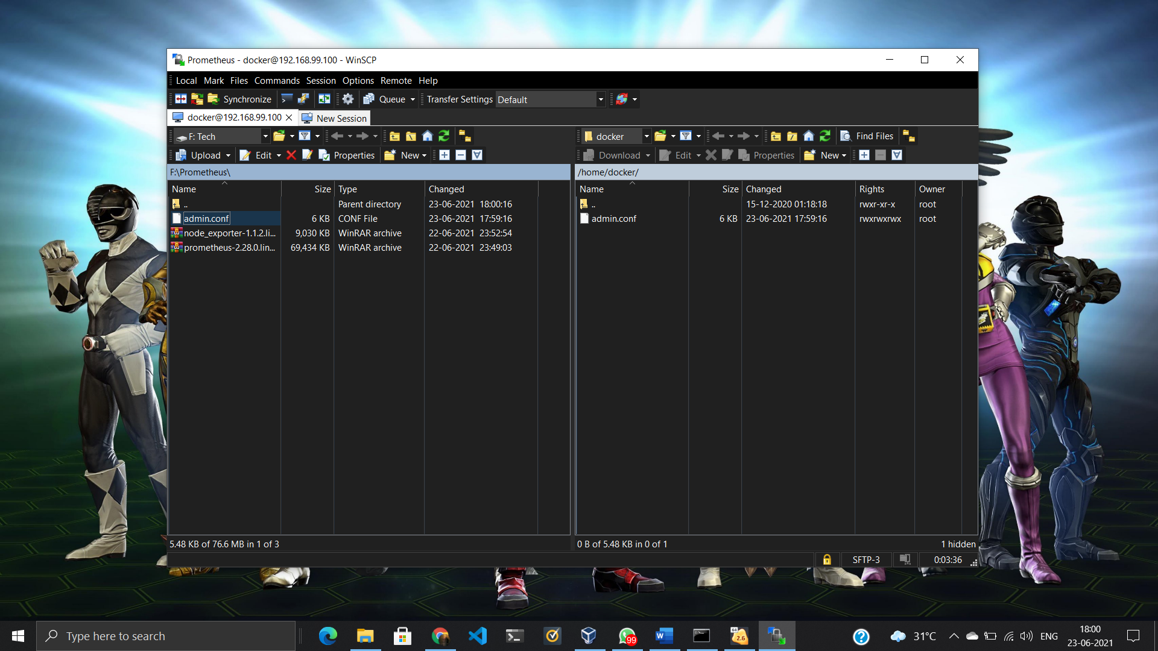

Launch the RHEL8 VM. Check the IP Address of system and again using WinSCP we can transfer admin.conf file from Windows to here i.e RHEL8 VM.

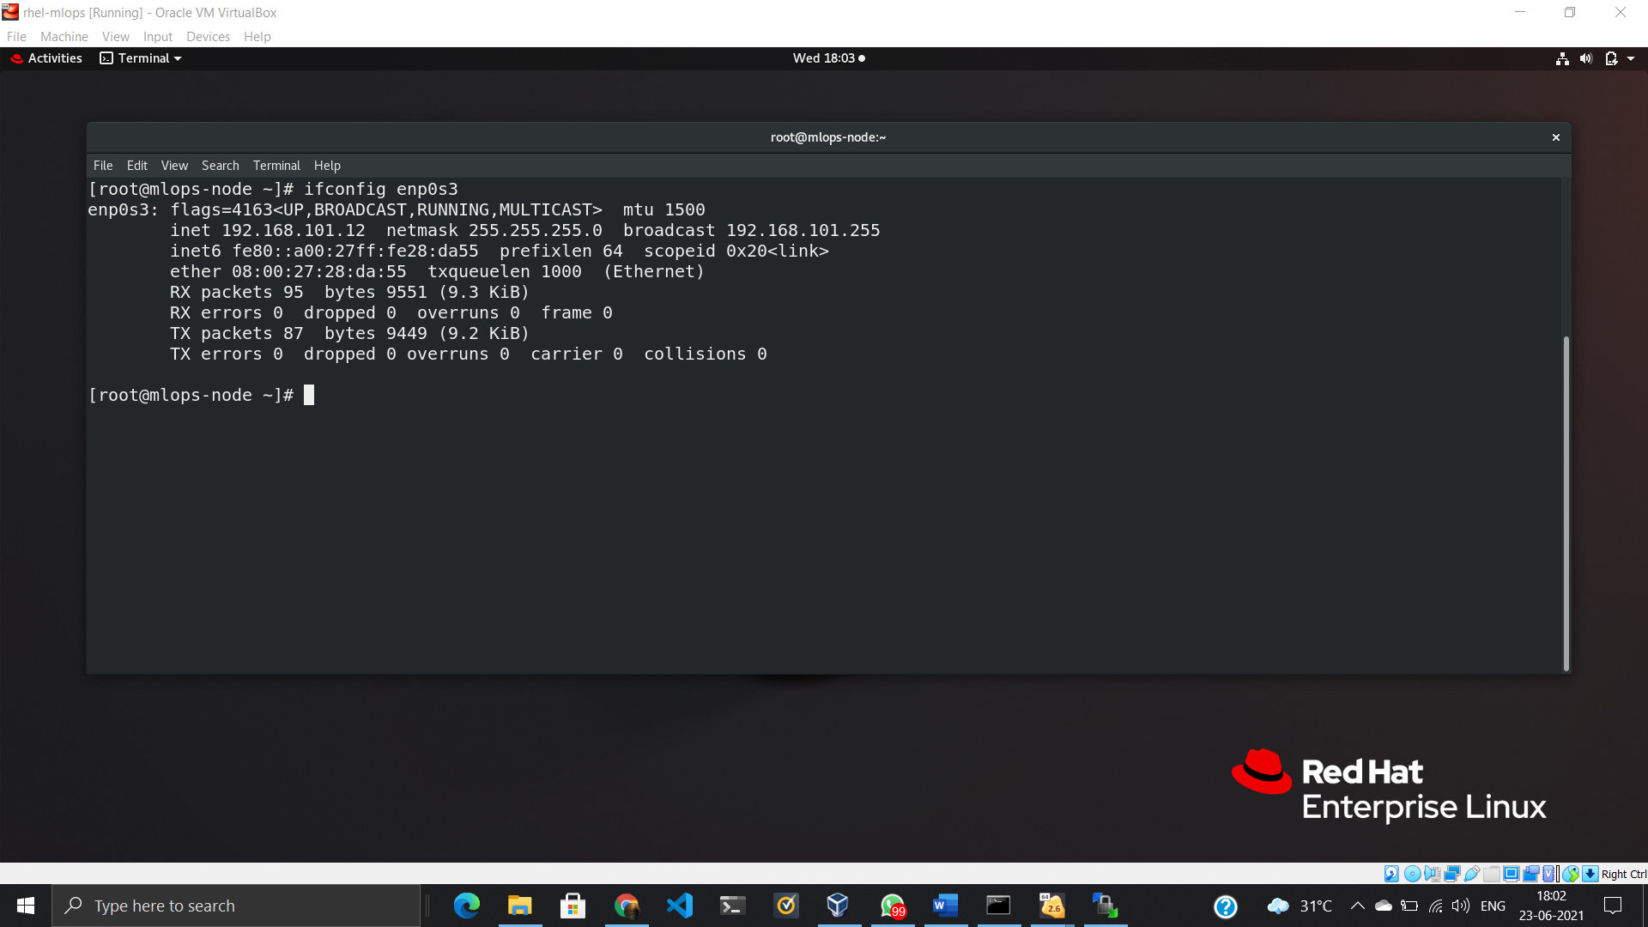

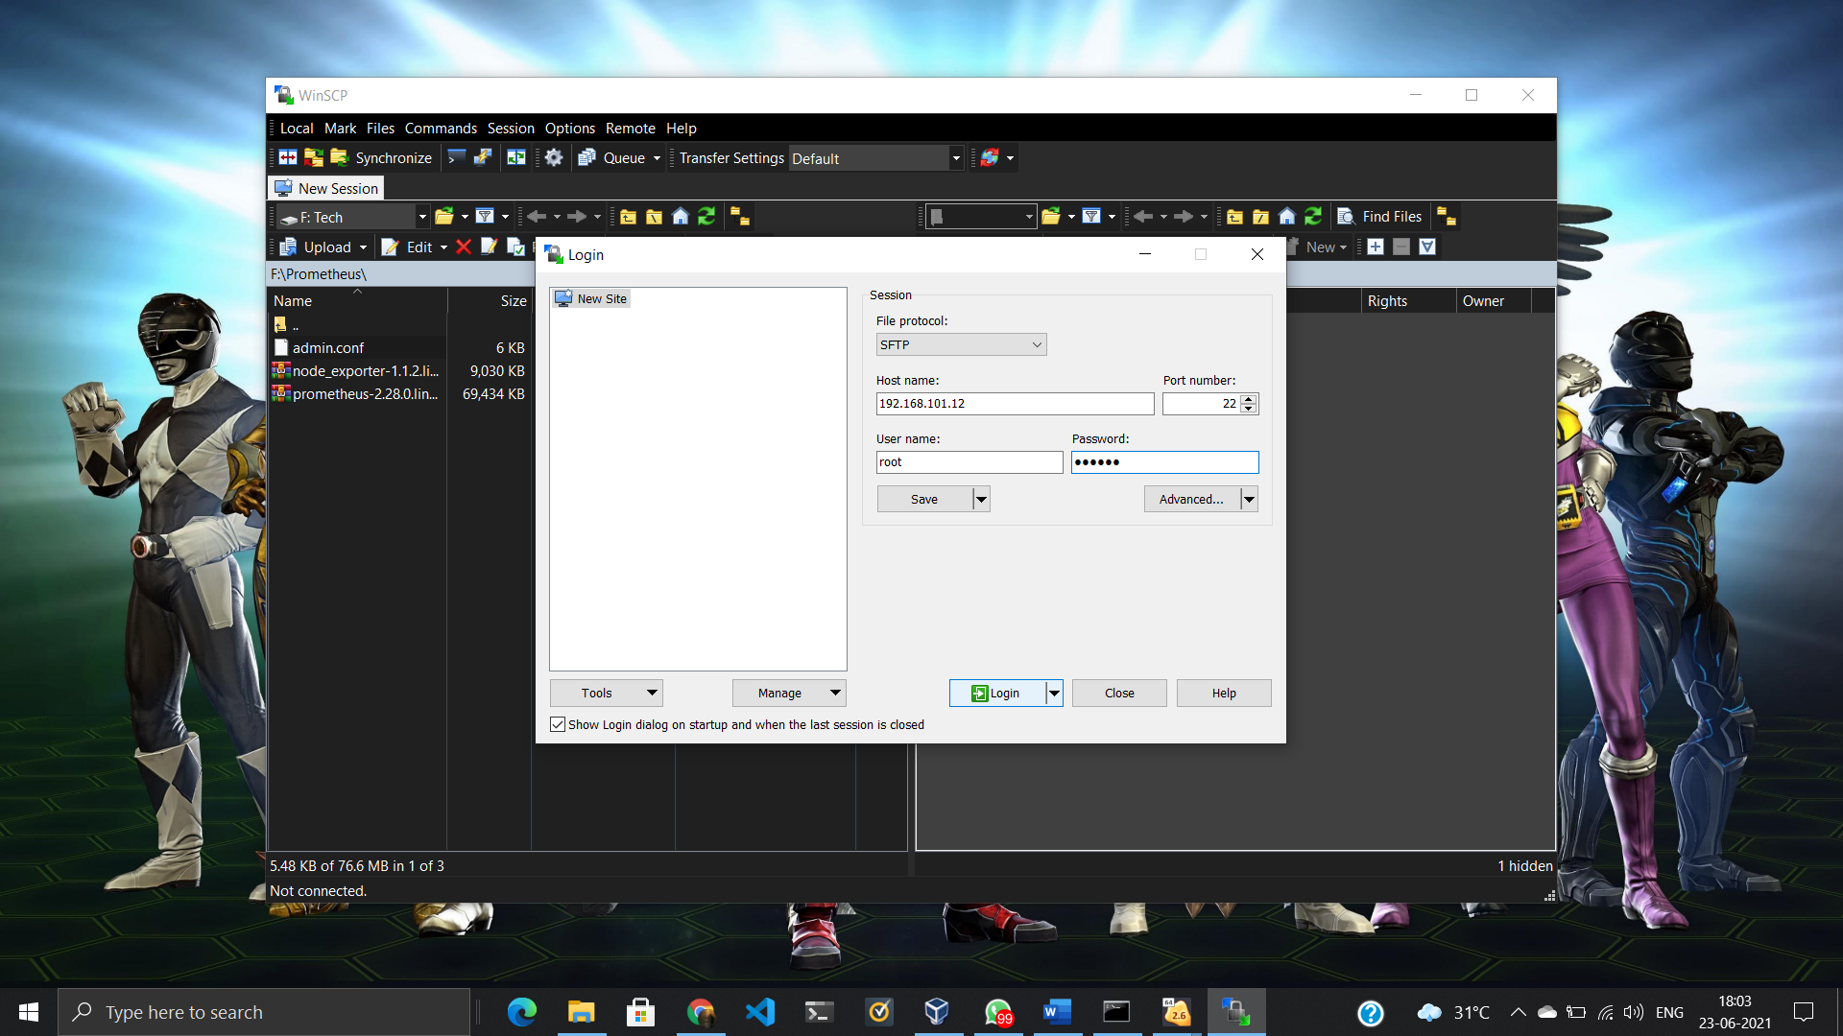

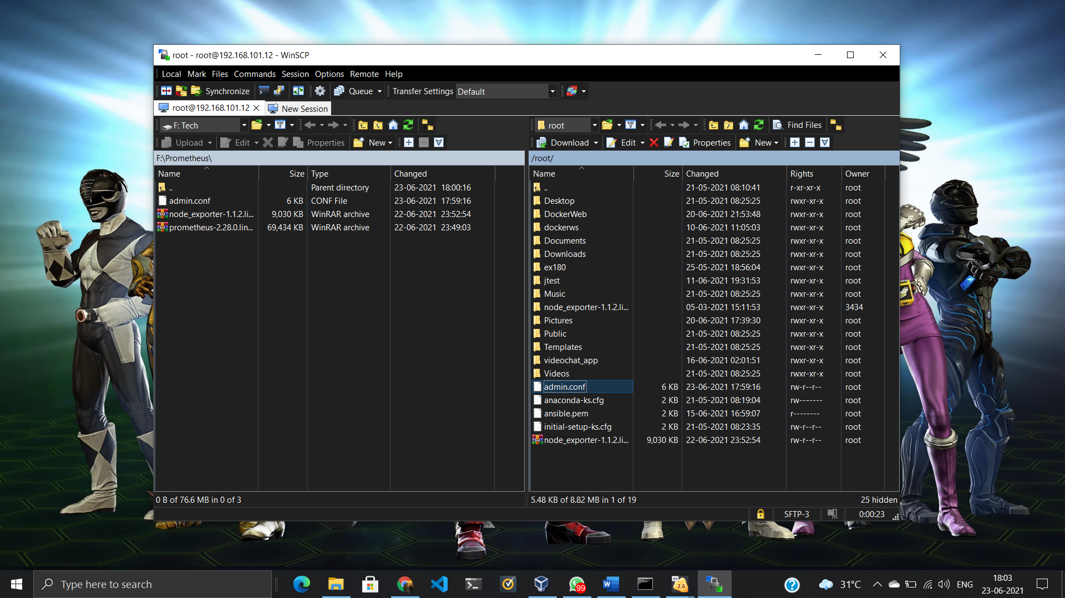

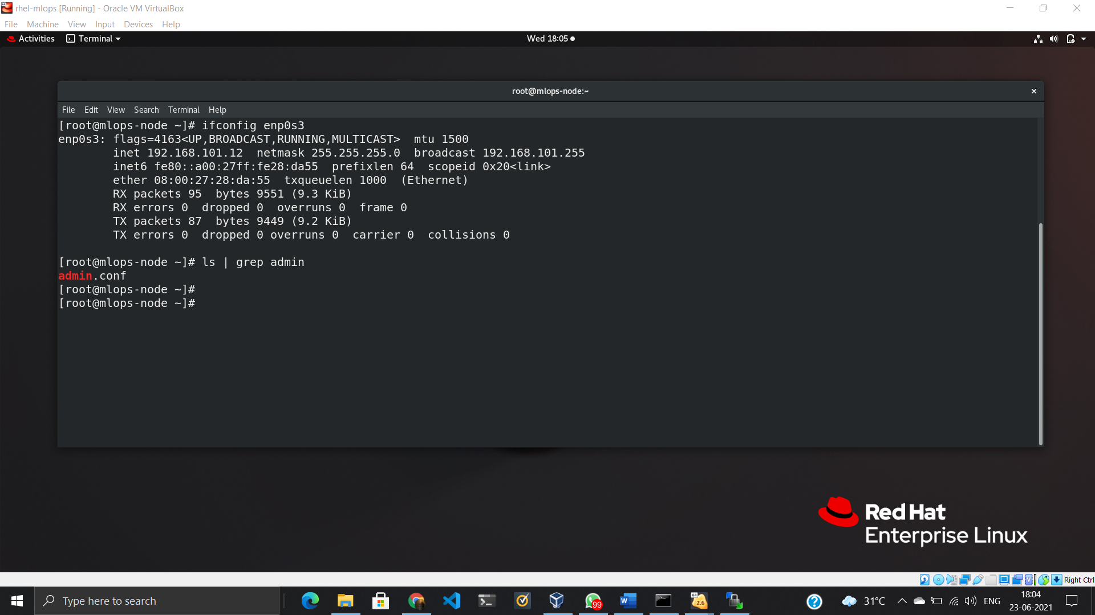

Now, we need kubectl software which acts as a client for k8s cluster. Copy below code in terminal and it will create a Kubernetes repo from which we can install kubectl.

<https://kubernetes.io/docs/setup/production-environment/tools/kubeadm/install-kubeadm/>

cat <<EOF | sudo tee /etc/yum.repos.d/kubernetes.repo

[kubernetes]

name=Kubernetes

baseurl=https://packages.cloud.google.com/yum/repos/kubernetes-el7-\$basearch

enabled=1

gpgcheck=1

repo_gpgcheck=1

gpgkey=https://packages.cloud.google.com/yum/doc/yum-key.gpg https://packages.cloud.google.com/yum/doc/rpm-package-key.gpg

exclude=kubelet kubeadm kubectl

EOF

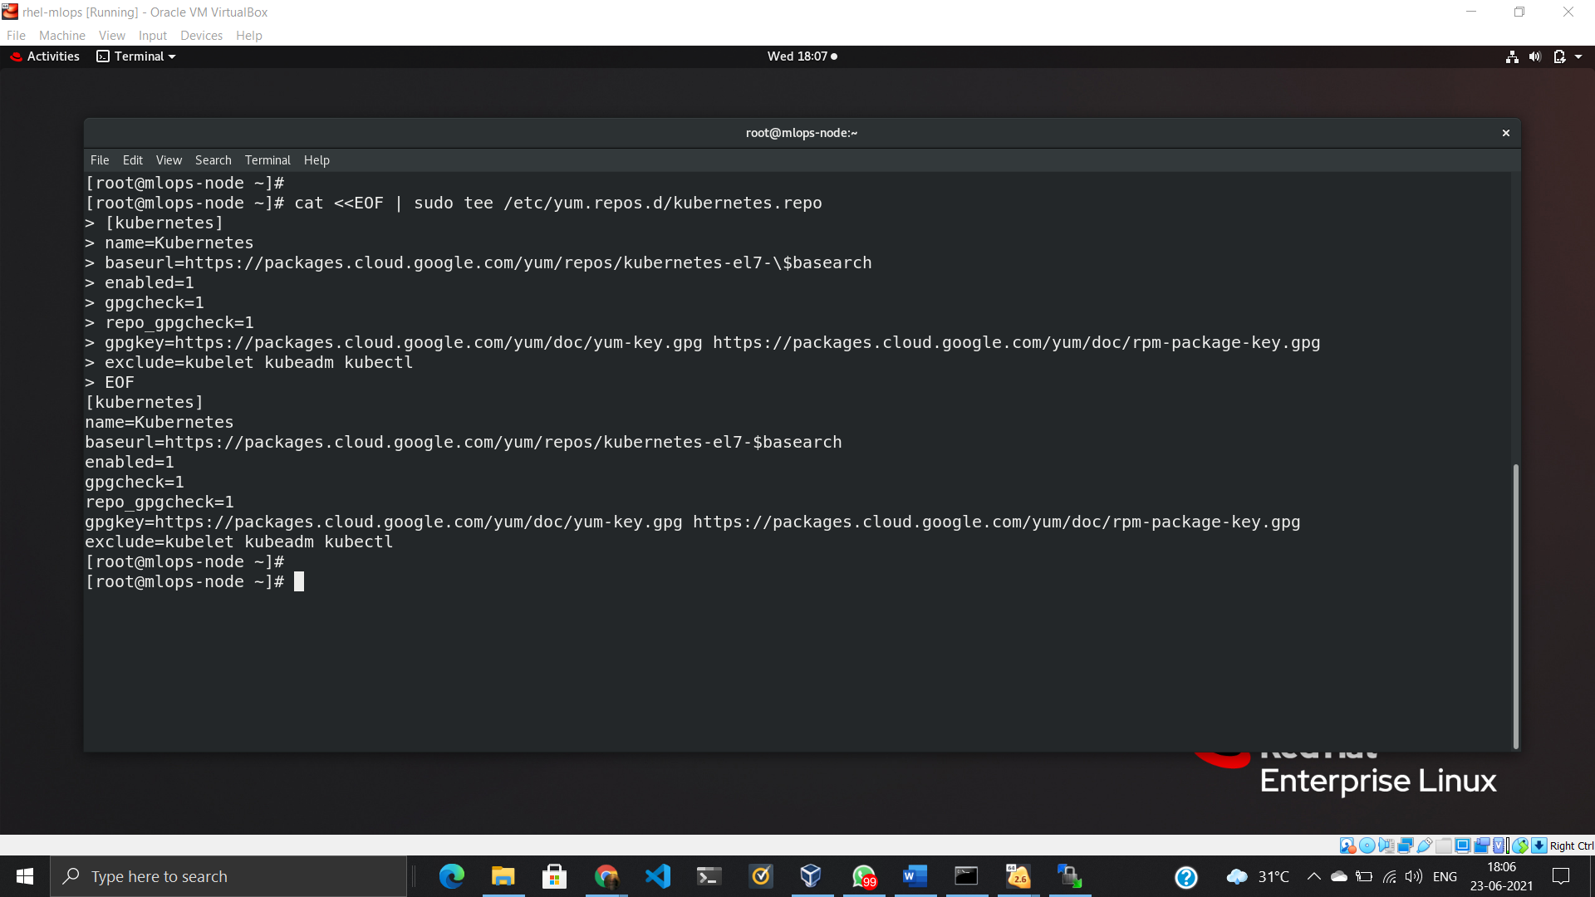

To install kubectl:

yum install kubectl

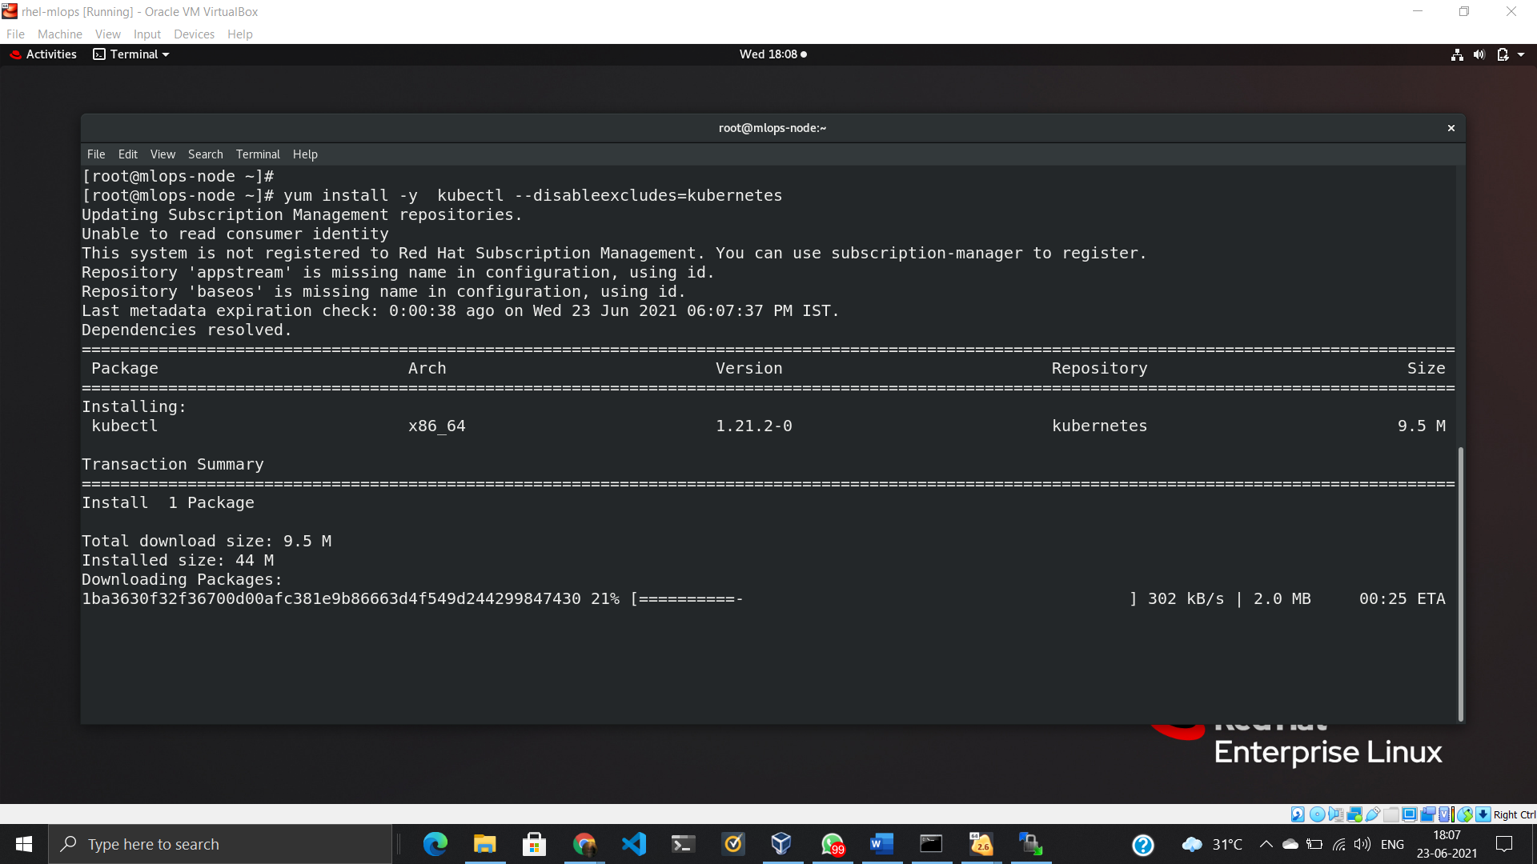

Now, we have to make a small change inside admin.conf file. Bydefault it has the hostname written as the server. So, we need to replace it by the IP Address of the Minikube VM.

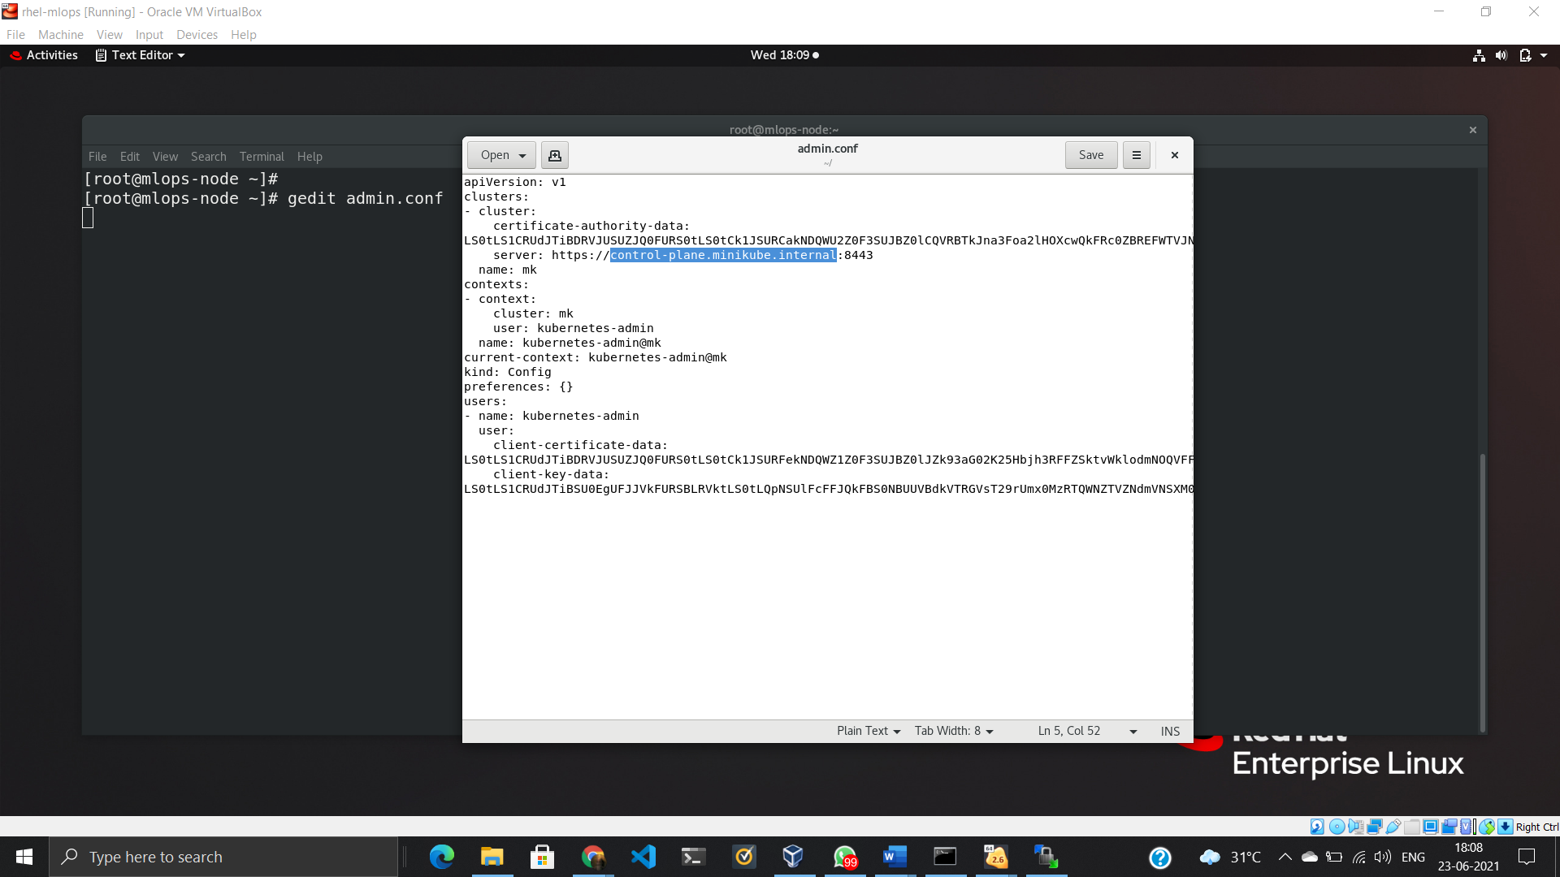

Put IP Address of Minikube VM.

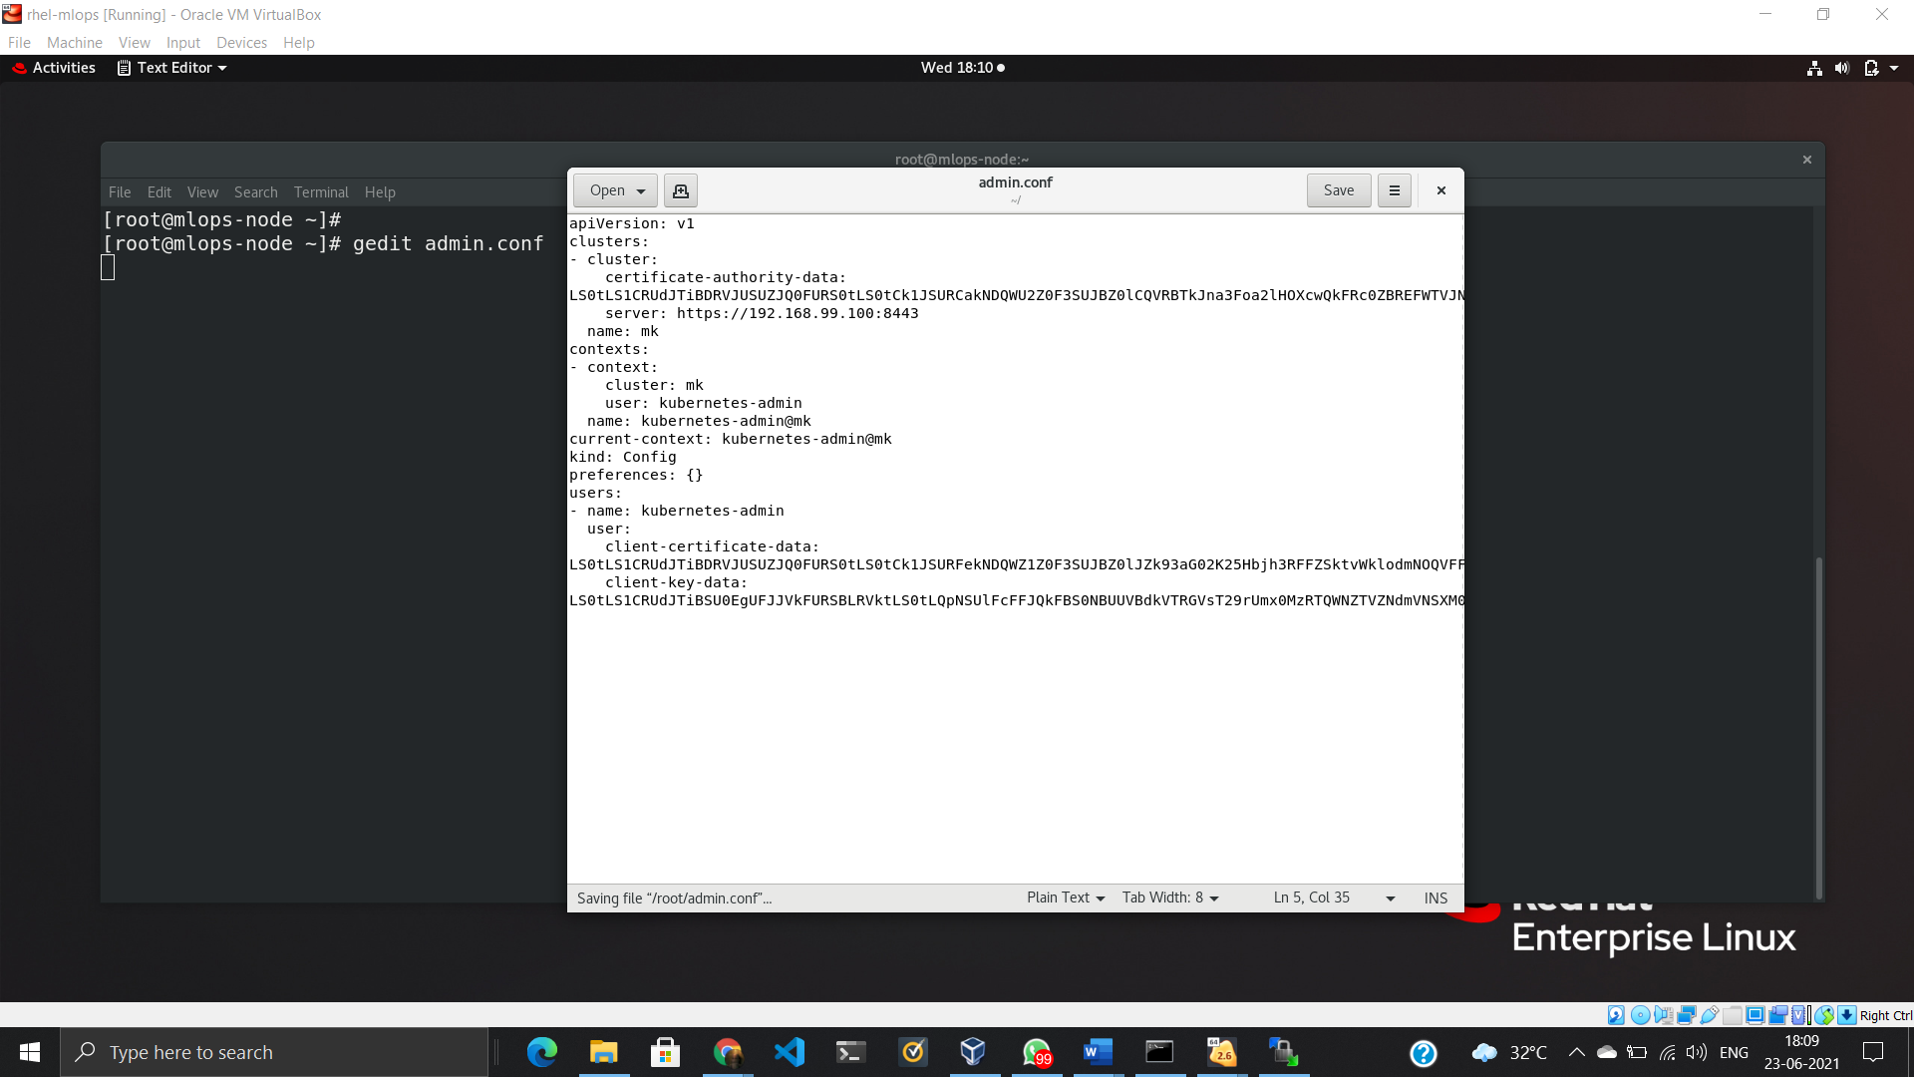

Now, close the VM and change the Network Adapter of VM.

Put 1st Adapter as NAT and 2nd Adapter as Host Only

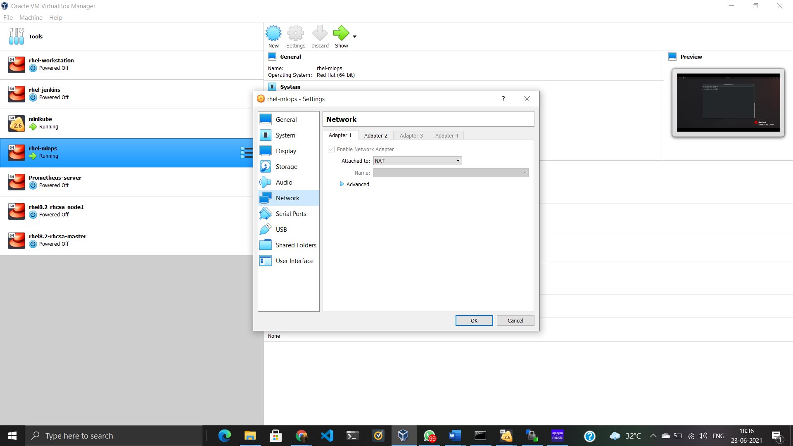

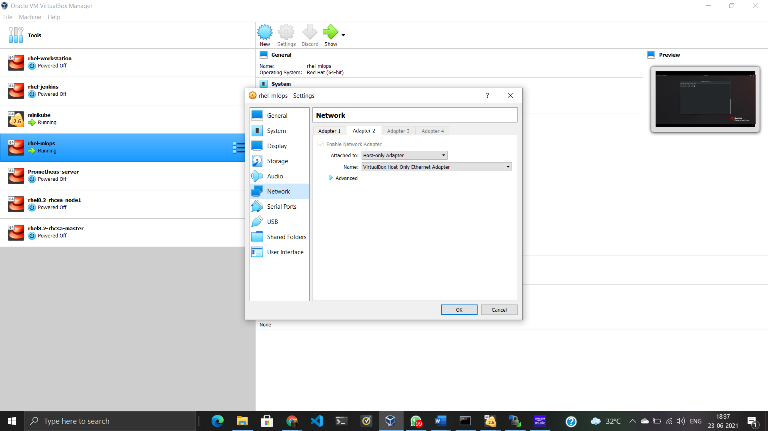

Start the VM. Create a working directory and put the admin.conf file in that directory.

And we can run kubectl commands by appending **--kubeconfig admin.conf** at last of the command.

Example:

**kubectl create deployment web-test --image=httpd --kubeconfig admin.conf**

